### Occupation Overview



Graphic Designers

**in Washington**

**Lightcast Q1 2023 Data Set |** [**www.economicmodeling.com**](http://www.economicmodeling.com/)

**Contents**

What is Lightcast Data? 1

**. .**

**. . . . . . . . . . . . . . . . . . . .**

Report Parameters 2

**. .**

**. . . . . . . . . . . . . . . .**

Executive Summary 3

**. .**

**. . . . . . . . . . . . . . . . .**

Jobs 4

**. .**

**. . . . .**

Compensation 7

**. .**

**. . . . . . . . . . . .**

Job Posting Activity 8

**. .**

**. . . . . . . . . . . . . . . .**

Demographics 13

**. . .**

**. . . . . . . . . . . .**

Occupational Programs 17

**. . .**

**. . . . . . . . . . . . . . . . . . . .**

Appendix A 20

**. . .**

**. . . . . . . . . .**

# What is Lightcast Data?

#### Lightcast data is a hybrid dataset derived from official government sources such as the US Census Bureau, Bureau of Economic Analysis, and Bureau of Labor Statistics. Leveraging the unique strengths of each source, our data modeling team creates an authoritative dataset that captures more than 99% of all workers in the United States. This core offering is then enriched with data from online social profiles, resumés, and job postings to give you a complete view of the workforce.

#### Lightcast data is frequently cited in major publications such as The Atlantic, Forbes, Harvard Business Review, The New York Times, The Wall Street Journal, and USA Today.



# Report Parameters

## 1 Occupation

27-1024 Graphic Designers

## 1 State

53 Washington

## Class of Worker

QCEW Employees and Non-QCEW Employees

#### The information in this report pertains to the chosen occupation and geographical area.

# Executive Summary

## Aggressive Job Posting Demand Over a Deep Supply of Regional Jobs

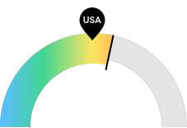

**6,064**

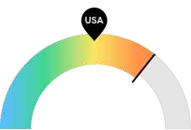

**$63,003**

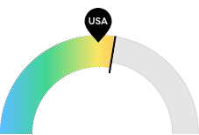

**131**

#### Jobs (2021)

Washington is a hotspot for this kind of job. The national average for an area this size is 4,998* employees, while there are 6,064 here.

#### Compensation

Earnings are high in Washington. The national median salary for Graphic Designers is $50,710, compared to $63,003 here.

#### Job Posting Demand

Job posting activity is high in Washington. The national average for an area this size is 113* job postings/mo, while there are 131 here.

**\*National average values are derived by taking the national value for Graphic Designers and scaling it down to account for the difference in overall workforce size between the nation and Washington. In other words, the values represent the national average adjusted for region size.**

# Jobs

## Regional Employment Is Higher Than the National Average

An average area of this size typically has 4,998* jobs, while there are 6,064 here. This higher than average supply of jobs may make it easier for workers in this field to find employment in your area.

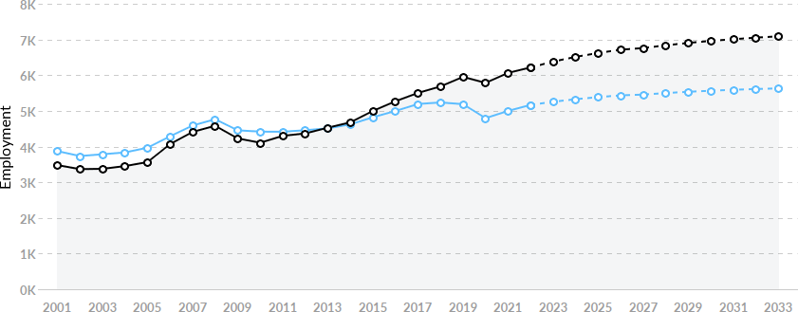

|  |  |  |  |  |
| --- | --- | --- | --- | --- |
| **Region** | **2021 Jobs** | **2030 Jobs** | **Change** | **% Change** |
| * **Washington** | **6,064** | **6,960** | **896** | **14.8%** |
| * **National Average** | **4,998** | **5,564** | **566** | **11.3%** |

**\*National average values are derived by taking the national value for Graphic Designers and scaling it down to account for the difference in overall workforce size between the nation and Washington. In other words, the values represent the national average adjusted for region size.**

## Regional Breakdown

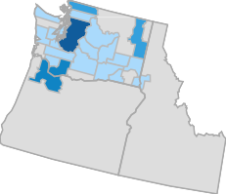

|  |  |
| --- | --- |
| **MSA** | **2021 Jobs** |
| **Seattle-Tacoma-Bellevue, WA** | **4,561** |
| **Portland-Vancouver-Hillsboro, OR-WA** | **2,194** |
| **Spokane-Spokane Valley, WA** | **354** |
| **Bellingham, WA** | **172** |
| **Olympia-Lacey-Tumwater, WA** | **118** |

## Most Jobs are Found in the Electronic Shopping and Mail-Order Houses Industry Sector

|  |  |  |
| --- | --- | --- |
|  |  | **% of Occupation in Industry** |
| **Industry** | **(2021)** |
| **⬤** | **Electronic Shopping and Mail-Order Houses** | **13.9%** |
| **⬤** | **Specialized Design Services** | **8.9%** |
| **⬤** | **Software Publishers** | **7.0%** |
| **⬤** | **Advertising, Public Relations, and Related Services** | **6.3%** |
| **⬤** | **Other Miscellaneous Manufacturing** | **5.1%** |
| **⬤** | **Printing and Related Support Activities** | **5.0%** |
| **⬤** | **Other** | **53.8%** |

# Compensation

## Regional Compensation Is 24% Higher Than National Compensation

For Graphic Designers, the 2021 median wage in Washington is $63,003, while the national median wage is $50,710.

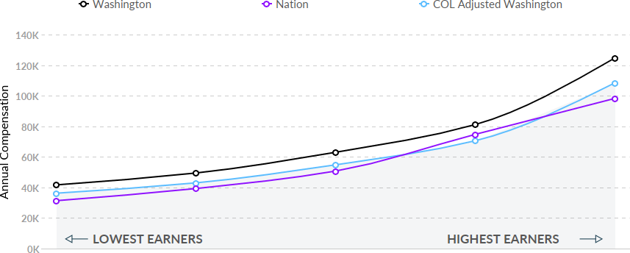

# Job Posting Activity



#### 3,140 Unique Job Postings

**The number of unique postings for this job from Jan 2021 to Dec 2022.**

#### 1046 Employers Competing

**All employers in the region who posted for this job from Jan 2021 to Dec 2022.**

#### 31 Day Median Duration

**Posting duration is the same as what's typical in the region.**

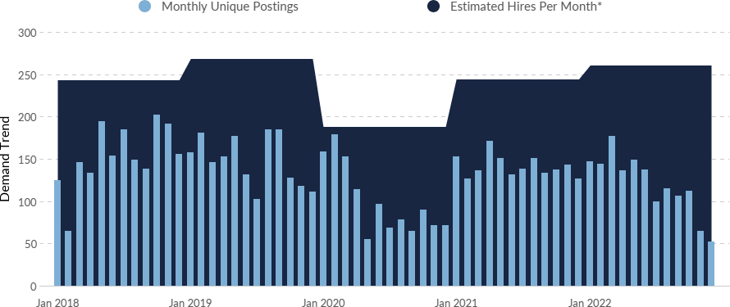

|  |  |  |
| --- | --- | --- |
| **Occupation** | **Avg Monthly Postings (Jan 2021 - Dec 2022)** | **Avg Monthly Hires (Jan 2021 - Dec 2022)** |
| **Graphic Designers** | **131** | **252** |

**\*A hire is reported by the Quarterly Workforce Indicators when an individual's Social Security Number appears on a company's payroll and was not there the quarter before. Lightcast hires are calculated using a combination of Lightcast jobs data, information on separation rates from the Bureau of Labor Statistics (BLS), and industry-based hires data from the Census Bureau.**

Top Companies Unique Postings Top Job Titles Unique Postings

**Amazon 108 ** **Graphic Designers 891 **

**Robert Half 103 ** **Visual Designers 360 **

Aquent 96  Partner Graphic Designers 137 

**Randstad 85 ** **Production Designers 93 **

**Kforce 44 ** **Production Artists 80 **

**Creative Circle 40 ** **UX Visual Designers 62 **

**CompuCom 31 ** **UI/Visual Designers 54 **

**Nordstrom 26 ** **Visual Graphic Designers 54 **

**Aston Carter 24 ** **Marketing Graphic Designers 36**

**Run Studios 22 ** **Creative Designers 34**

## Top Specialized Skills

 Frequency in Job Postings  Frequency in Profiles

**Graphic Design Adobe Illustrator Adobe Photoshop**

Skills Postings

**Marketing**

**Adobe InDesign Adobe Creative Suite**

**Visual Design Typography Illustration Branding**

**0% 10% 20% 30% 40% 50%**

% of Total Postings

Profiles

% of Total Profiles

Graphic Design 31%

5,989

55%

1,737

Adobe Illustrator 26%

5,002

51%

1,608

Adobe Photoshop 1,536 49% 5,371 28%

Marketing 1,207 38% 3,803 20%

Adobe InDesign 1,122 36% 3,716 19%

Adobe Creative Suite 929 30% 4,151 22%

Visual Design 849 27% 1,206 6%

Typography 787 25% 2,387 12%

Illustration 595 19% 3,194 17%

Branding 480 15% 2,457 13%

## Top Common Skills

Frequency in Job Postings Frequency in Profiles

**Communications Detail Oriented**

**Presentations**

Skills Postings

**Self-Motivation**

**Microsoft PowerPoint Time Management**

**Ability To Meet Deadlines**

**Sales Problem Solving Microsoft Office**

**0% 10% 20% 30% 40% 50%**

% of Total Postings Profiles

% of Total Profiles

Communications 0%

1

1,860

51%

1,611

Detail Oriented 1%

190

33%

1,032

Presentations 882 28% 1,321 7%

Self-Motivation 586 19% 59 0%

Microsoft PowerPoint 540 17% 1,503 8%

Time Management 490 16% 582 3%

Ability To Meet Deadlines 474 15% 188 1%

Sales 467 15% 2,473 13%

Problem Solving 440 14% 391 2%

Microsoft Office 440 14% 2,736 14%

## Top Software Skills

Frequency in Job Postings Frequency in Profiles

**Adobe Illustrator**

**Adobe Photoshop Adobe InDesign**

**Adobe Creative Suite Microsoft PowerPoint Microsoft Office**

Skills Postings

**Figma (Design Software)**

**Adobe After Effects HyperText Markup Language (HTML) Cascading Style Sheets (CSS)**

**0% 10% 20% 30% 40% 50%**

% of Total Postings Profiles

% of Total Profiles

Adobe Illustrator

1,608

51%

5,002

26%

Adobe Photoshop 1,536 49% 5,371 28%

Adobe InDesign 1,122 36% 3,716 19%

Adobe Creative Suite 929 30% 4,151 22%

Microsoft PowerPoint 540 17% 1,503 8%

Microsoft Office 440 14% 2,736 14%

Figma (Design Software) 439 14% 102 1%

Adobe After Effects 362 12% 952 5%

HyperText Markup Language (HTML)

348 11% 1,212 6%

Cascading Style Sheets (CSS)

292 9% 937 5%

# Demographics

## Retirement Risk Is Low, While Overall Diversity Is About Average

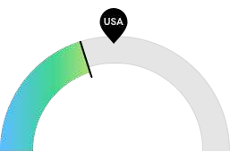

**807**

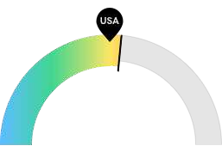

**1,878**

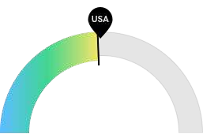

**3,158**

#### Retiring Soon

Retirement risk is low in Washington. The national average for an area this size is 1,086* employees 55 or older, while there are 807 here.

#### Racial Diversity

Racial diversity is about average in Washington. The national average for an area this size is 1,720* racially diverse employees, while there are 1,878 here.

#### Gender Diversity

Gender diversity is about average in Washington. The national average for an area this size is 3,268* female employees, while there are 3,158 here.

**\*National average values are derived by taking the national value for Graphic Designers and scaling it down to account for the difference in overall workforce size between the nation and Washington. In other words, the values represent the national average adjusted for region size.**

## Occupation Age Breakdown

|  |  |  |  |
| --- | --- | --- | --- |
|  | | **% of Jobs** | **Jobs** |
| **⬤** | **14-18** | **0.3%** | **20** |
| **⬤** | **19-24** | **7.3%** | **452** |
| **⬤** | **25-34** | **36.7%** | **2,285** |
| **⬤** | **35-44** | **26.1%** | **1,623** |
| **⬤** | **45-54** | **16.6%** | **1,031** |
| **⬤** | **55-64** | **9.7%** | **606** |
| **⬤** | **65+** | **3.2%** | **201** |

## Occupation Race/Ethnicity Breakdown

|  |  |  |  |
| --- | --- | --- | --- |
|  | | **% of Jobs** | **Jobs** |
| **⬤** | **White** | **69.8%** | **4,339** |
| **⬤** | **Asian** | **17.7%** | **1,100** |
| **⬤** | **Hispanic or Latino** | **6.9%** | **431** |
| **⬤** | **Two or More Races** | **3.4%** | **214** |
| **⬤** | **Black or African American** | **1.5%** | **92** |
| **⬤** | **Native Hawaiian or Other Pacific Islander** | **0.4%** | **23** |
| **⬤** | **American Indian or Alaska Native** | **0.3%** | **18** |

## Occupation Gender Breakdown

% of Jobs Jobs

⬤ Males 49.2% 3,060

⬤ Females 50.8% 3,158

## National Educational Attainment

|  |  |  |
| --- | --- | --- |
|  | | **% of Jobs** |
| **⬤** | **Less than high school diploma** | **1.3%** |
| **⬤** | **High school diploma or equivalent** | **5.4%** |
| **⬤** | **Some college, no degree** | **13.8%** |
| **⬤** | **Associate's degree** | **12.3%** |
| **⬤** | **Bachelor's degree** | **58.8%** |
| **⬤** | **Master's degree** | **7.1%** |
| **⬤** | **Doctoral or professional degree** | **1.3%** |

# Occupational Programs



#### 21 Programs

**Of the programs that can train for this job, 21 have produced completions in the last 5 years.**

#### 1,946 Completions (2021)

**The completions from all regional institutions for all degree types.**

#### 712 Openings (2021)

**The average number of openings for an occupation in the region is 680.**

CIP Code Top Programs Completions (2021)

11.0801 Web Page, Digital/Multimedia and Information Resources D… 332 

09.0702 Digital Communication and Media/Multimedia 297 

50.0401 Design and Visual Communications, General 261 

50.0701 Art/Art Studies, General 233 

10.0304 Animation, Interactive Technology, Video Graphics, and Sp… 151 

11.0803 Computer Graphics 121 

09.0900 Public Relations, Advertising, and Applied Communication 107 

50.0702 Fine/Studio Arts, General 94 

09.0903 Advertising 76 

50.0402 Commercial and Advertising Art 68 

Top Schools Completions (2021)

Washington State University 358 

University of Washington-Seattle Campus 248 

Western Washington University 150 

Seattle University 102 

Eastern Washington University 98 

DigiPen Institute of Technology 94 

Lake Washington Institute of Technology 87 

Spokane Community College 74 

Academy of Interactive Entertainment 70 

Shoreline Community College 66 

# Appendix A

Graphic Designers (SOC 27-1024):

Design or create graphics to meet specific commercial or promotional needs, such as packaging, displays, or logos. May use a variety of mediums to achieve artistic or decorative effects. Excludes Web and Digital Interface Designers (15-1255).

Sample of Reported Job Titles:

Visual Designer Graphic Artist Graphic Designer Production Artist Publications Designer Online Producer Designer

Artist

Production Designer Layout Artist

Related O*NET Occupation:

Graphic Designers (27-1024.00)